Here are excellent beginner-friendly to intermediate classification datasets very similar to the Pima Indian Diabetes dataset — small, clean, tabular, and perfect for practicing ML models like Logistic Regression, Random Forest, SVM, NN, etc.
I included dataset link, description, target variable, and why it’s similar.

✅ 1. Breast Cancer Wisconsin Dataset (Diagnosis: Benign vs Malignant)
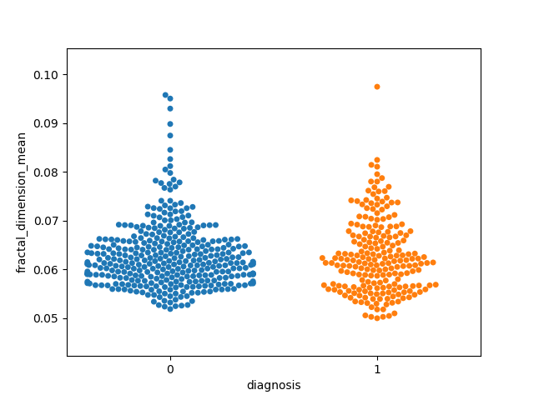
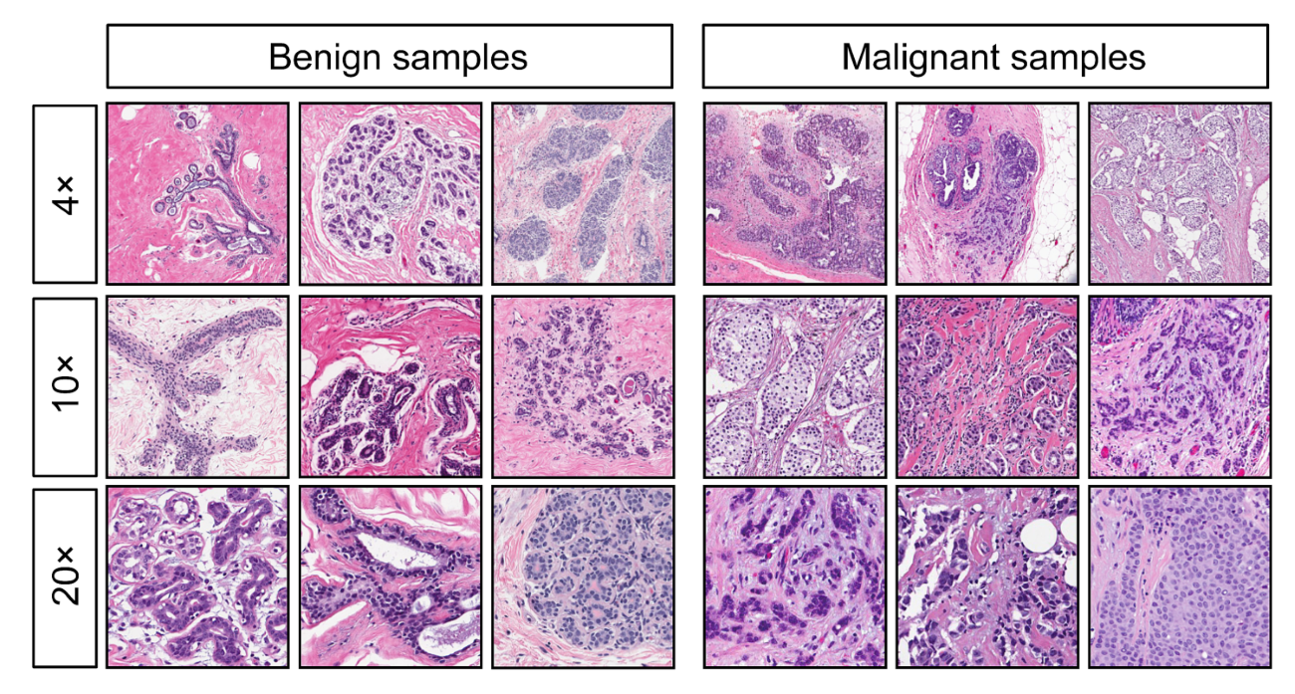
Link: Available in sklearn
from sklearn.datasets import load_breast_cancer
Target:
- 0 = Malignant
- 1 = Benign
Why similar:
- Small dataset
- Binary classification
- Medical features
- Very common for ML practice

✅ 2. Heart Disease Dataset (Cleveland Heart Disease)
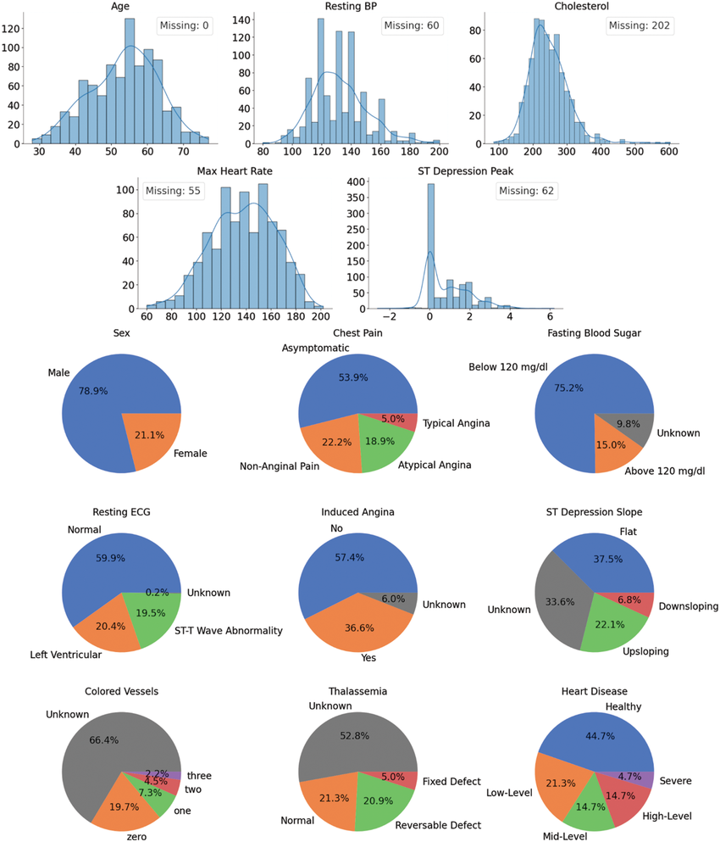
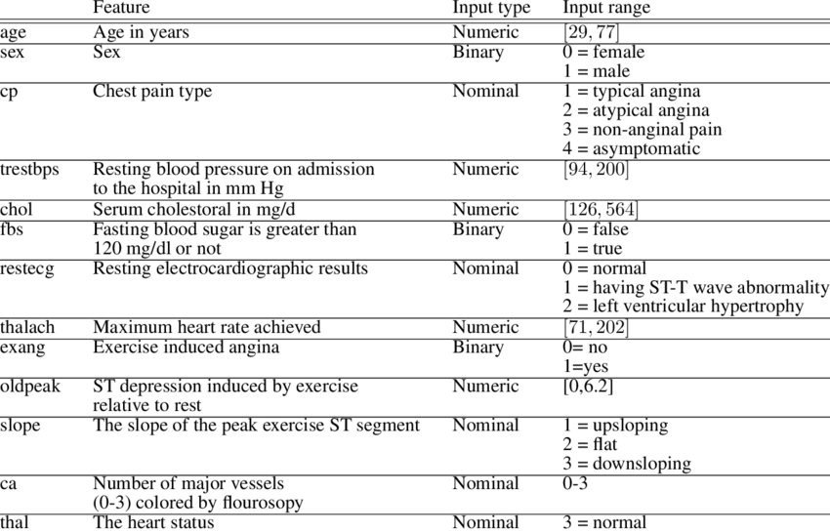
Link:
UCI ML Repository (Heart Disease)
Target:
- 0 = No Heart Disease
- 1 = Heart Disease Present
Why similar:
- Health-related prediction
- Clinical measurements
- Similar difficulty as Pima Diabetes

✅ 3. Stroke Prediction Dataset


Link: Kaggle – Stroke Prediction Dataset
Target:
- 0 = No stroke
- 1 = Stroke
Why similar:
- Binary classification
- Health measurements (BMI, glucose, age, etc.)
- Some missing values (good practice)

✅ 4. Liver Disease Dataset (Indian Liver Patient Dataset - ILPD)
Link: UCI ML Repository — ILPD
Target:
- 0 = Not liver patient
- 1 = Liver patient
Why similar:
- Indian patient dataset
- Medical classification
- Medium difficulty (slightly imbalanced)

✅ 5. Chronic Kidney Disease (CKD) Dataset
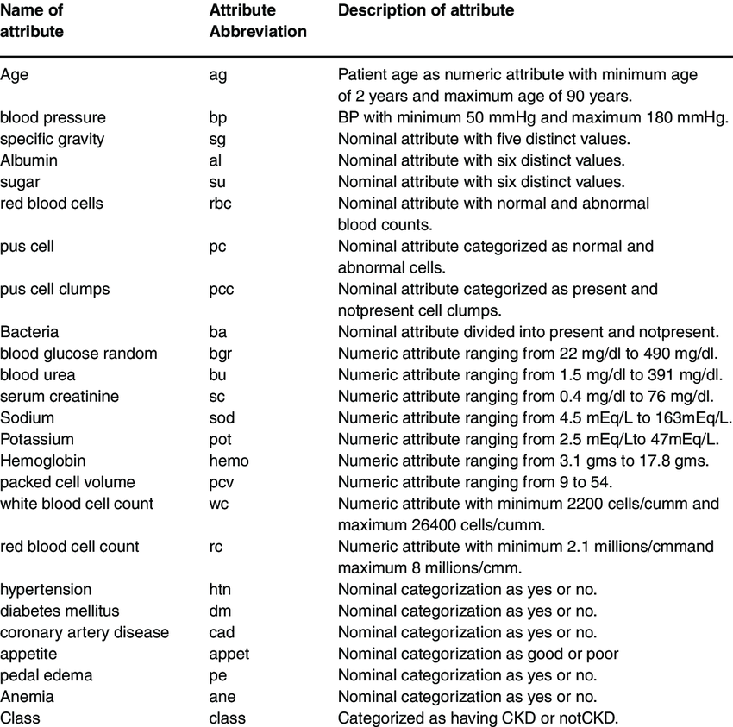
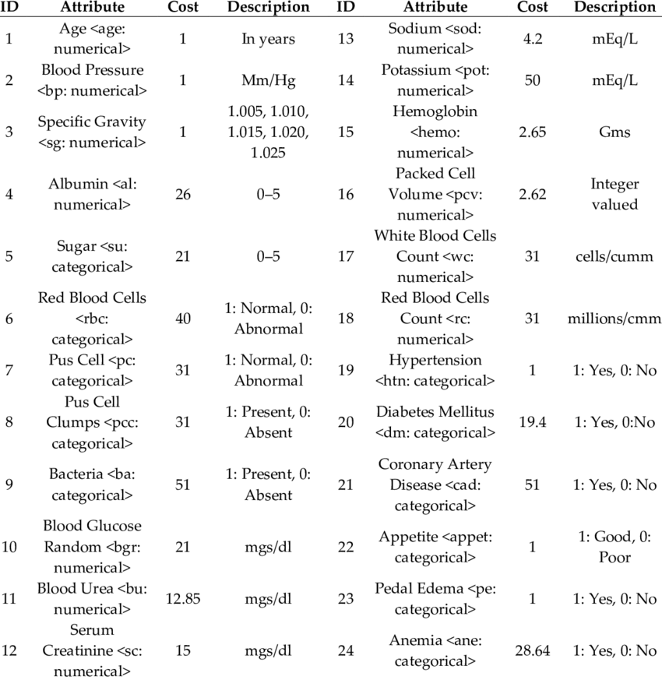
Link: UCI ML Repository
Target:
- 0 = No CKD
- 1 = CKD detected
Why similar:
- Medical report values
- Binary output
- Has categorical + numeric data → good practice for preprocessing

✅ 6. Hepatitis Dataset
Link: UCI Hepatitis Dataset
Target:
- 0 = Die
- 1 = Live
Why similar:
- Healthcare classification
- Classic ML dataset

✅ 7. Framingham Heart Study Dataset
Link: Kaggle — Framingham Heart Study
Target:
- 0 = No heart disease risk
- 1 = 10-year risk of CHD
Why similar:
- Medical predictors (cholesterol, BP)
- Real clinical dataset
- Good for logistic regression

📌 BONUS: Non-medical but similar difficulty

8. Bank Marketing Dataset (Yes/No prediction)
Target: Whether a customer will subscribe to a term deposit.
Good for imbalanced classification practice.

⭐ Recommended Learning Path (Based on your progress)
Since you already practiced with Pima Diabetes, do datasets in this order:
1️⃣ Breast Cancer
2️⃣ Heart Disease
3️⃣ CKD Dataset
4️⃣ Liver Disease (harder)
5️⃣ Stroke Prediction
6️⃣ Framingham (more preprocessing needed)

If you want, I can also give:
✅ Ready-to-run notebook for each dataset
✅ EDA + preprocessing + modeling template
✅ Practice questions
✅ Code for scaling, ROC–AUC, confusion matrix, etc.
Just tell me:
“Give me notebook template for dataset X”
Great — here is a ready-to-use, professional machine-learning notebook template you can apply to ANY classification dataset (Breast Cancer, Heart Disease, CKD, Liver Disease, Stroke, etc.).
This follows the workflow:
- Load dataset
- Explore
- Clean
- Preprocess
- Train
- Evaluate
- Predict on new sample
It will run as is once you replace the dataset-loading block.

✅ Universal Classification Notebook Template (Fully Explained)
# ---------------------------------------------------------
# 1. IMPORT REQUIRED LIBRARIES
# ---------------------------------------------------------
import pandas as pd
import numpy as np
import matplotlib.pyplot as plt
import seaborn as sns

from sklearn.model_selection import train_test_split
from sklearn.preprocessing import StandardScaler
from sklearn.metrics import accuracy_score, confusion_matrix, classification_report, roc_auc_score
from sklearn.linear_model import LogisticRegression

# set visualization style
sns.set(style="whitegrid")

🔽 2. LOAD YOUR DATASET (EDIT THIS PART ONLY)
👉 Example: Breast Cancer (built-in)
from sklearn.datasets import load_breast_cancer
data = load_breast_cancer()
df = pd.DataFrame(data.data, columns=data.feature_names)
df["target"] = data.target
👉 Example: Load CSV (Heart Disease, CKD, Stroke, ILPD etc.)
df = pd.read_csv("your_dataset.csv")

---------------------------------------------------------

3. INITIAL DATA CHECK

---------------------------------------------------------
print(df.head())
print(df.info())
print(df.describe())
print(df.isnull().sum())

---------------------------------------------------------

4. HANDLE MISSING VALUES

---------------------------------------------------------
# Simple strategy (for numeric columns)
df = df.fillna(df.median())

---------------------------------------------------------

5. EDA (Exploratory Data Analysis)

---------------------------------------------------------
plt.figure(figsize=(6,4))
sns.countplot(x='target', data=df)
plt.title("Target Distribution")
plt.show()

# Correlation heatmap for numerical features
plt.figure(figsize=(12,8))
sns.heatmap(df.corr(), cmap='coolwarm')
plt.title("Feature Correlation Heatmap")
plt.show()

---------------------------------------------------------

6. SPLIT FEATURES AND LABEL

---------------------------------------------------------
X = df.drop("target", axis=1)
y = df["target"]

X_train, X_test, y_train, y_test = train_test_split(
X, y, test_size=0.3, random_state=42
)

---------------------------------------------------------

7. FEATURE SCALING

---------------------------------------------------------
scaler = StandardScaler()
X_train_scaled = scaler.fit_transform(X_train)
X_test_scaled = scaler.transform(X_test)

---------------------------------------------------------

8. MODEL TRAINING (Logistic Regression)

---------------------------------------------------------
model = LogisticRegression(max_iter=1000, solver="liblinear")
model.fit(X_train_scaled, y_train)

---------------------------------------------------------

9. MODEL PREDICTION

---------------------------------------------------------
y_pred = model.predict(X_test_scaled)
y_prob = model.predict_proba(X_test_scaled)[:,1]

---------------------------------------------------------

10. MODEL EVALUATION

---------------------------------------------------------
print("Accuracy:", accuracy_score(y_test, y_pred))
print("\nClassification Report:\n")
print(classification_report(y_test, y_pred))
print("ROC–AUC Score:", roc_auc_score(y_test, y_prob))
Confusion Matrix:
plt.figure(figsize=(6,4))
cm = confusion_matrix(y_test, y_pred)
sns.heatmap(cm, annot=True, fmt='d', cmap='Blues')
plt.xlabel("Predicted")
plt.ylabel("Actual")
plt.title("Confusion Matrix")
plt.show()

---------------------------------------------------------

11. PREDICT NEW SAMPLE

---------------------------------------------------------
👉 Example (EDIT values based on your dataset)
new_sample = pd.DataFrame({
"age": [55],
"trestbps": [130],
"chol": [250],
"thalach": [150],
# add all required features...
})

# scale using already-fitted scaler
new_sample_scaled = scaler.transform(new_sample)

prediction = model.predict(new_sample_scaled)[0]
probability = model.predict_proba(new_sample_scaled)[0][1]

print("Prediction:", "Positive" if prediction==1 else "Negative")
print("Probability of Class 1:", round(probability, 3))

🎯 Want a ready-to-run file?
Tell me which dataset you want:

Options
- Breast Cancer
- Heart Disease
- Stroke Prediction
- Chronic Kidney Disease (CKD)
- Liver Disease (ILPD)
- Hepatitis
- Titanic Survival
- Bank Marketing (term deposit prediction)
I will generate:
✅ Full notebook
✅ EDA
✅ Machine learning pipeline
✅ Confusion matrix & ROC curve
✅ New patient prediction section
Just reply:
“Give full notebook for dataset X”

